On the air

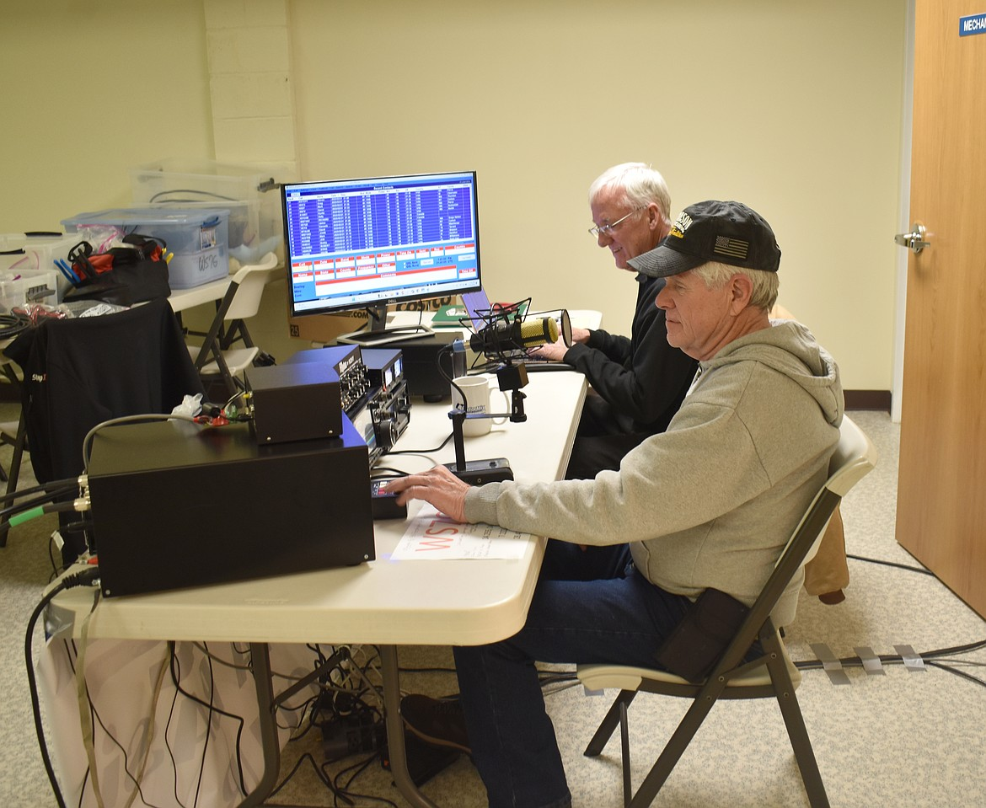
Ham radio enthusiasts Woody Jacobson, right, and Mike Wren make contacts up and down the West Coast Friday at the beginning of the Columbia Basin DX Club’s three-day event in honor of George Washington’s Birthday.
JOEL MARTIN/COLUMBIA BASIN HERALD
by JOEL MARTIN
Staff Writer | February 26, 2025 1:20 AM

GEORGE — The first president of the United States was wished a happy birthday around the world over the weekend.

“We contacted over 500 people all over the place,” said Brian Nielson, one of the organizers of the Columbia Basin DX Club’s ham radio event at the George Community Hall. Saturday would have been Washington’s 293rd birthday, and the club has held the event in George to mark the date for 20 years.

Woody Jacobson was working the microphone Friday, chatting with ham radio enthusiasts up and down the West Coast. Beside him, Mike Wren looked up the call signs of the people who responded in an online database, so Jacobson could have a name and location to attach to the voice coming out of the speaker. Every so often Jacobson would push a button and play a recorded message into the microphone.

“Whiskey Sierra Seven Golf special event station out of George, Wash. QRZ,” the recording said.

“We could transmit live, but if you do that all day it kind of gets wearing so we have it recorded,” Nielson said.

Whenever someone answered the message, Jacobson would open the mic and chat with them.

“Thank you for your efforts in recognizing our forefathers,” said Julie, who had answered the recording from Aumsville, Ore., about 10 miles east of Salem. “Blessings to you and 73 (ham radio code for ‘Best regards’).”
“God bless you too, Julie,” Jacobson said.

Ham radio tends to be a predominantly male hobby, Nielson explained, so female operators are less common.

“One of the big things is the pitch of the voice on the air,” he said. “(Female voices) come through a lot better.”

“I’ve been a ham radio operator for 20-some years,” said Nita Lyman, who had made the trip from Cliffdell, on the road over Mt. Rainier, for the occasion. “I love ham radio people. They’re my second family.”

Lyman served as a volunteer emergency radio operator keeping communications open following the Oso landslide in 2014, in which 43 people died, she said.

The Columbia Basin DX Club has participated in other ham clubs’ events as well, Nielson said. The club has a large display of postcards it’s gotten from clubs and events around the world, from Japan to Italy to Bhutan to Malpelo Island, a tiny atoll off the coast of Colombia.

The signal in George made it to some pretty far-flung places, Nielson said, especially Saturday.

“The farthest away would probably be in Bolivia,” he said. “I think we had … a Swedish station, and then one in Nigeria. We had a couple of South American and quite a few Caribbean stations.”

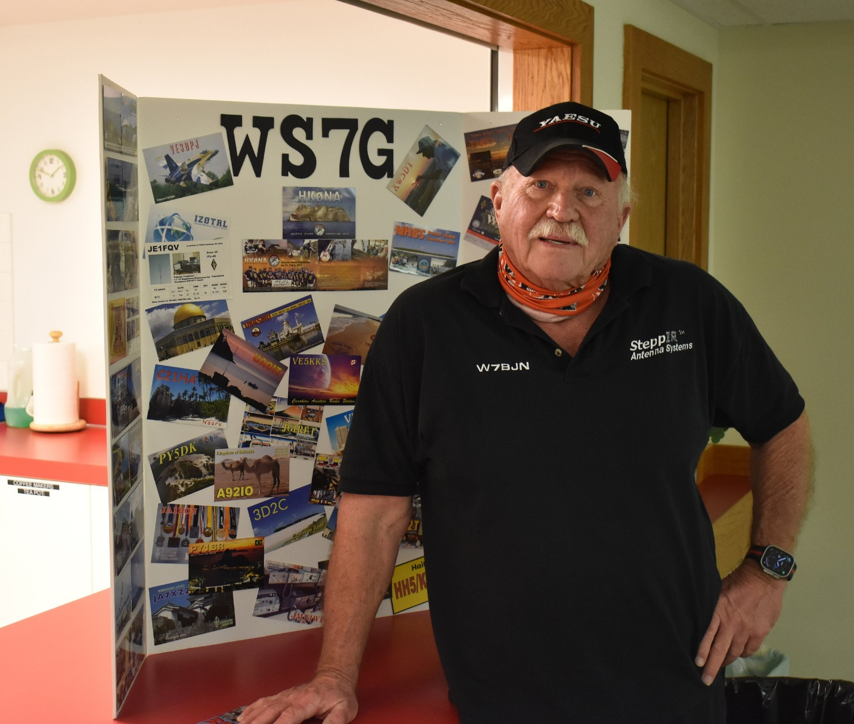 Brian Nielson, founder of the Columbia Basin DX Club, stands in front of a collection of postcards the club has received from various other ham clubs and events around the world.

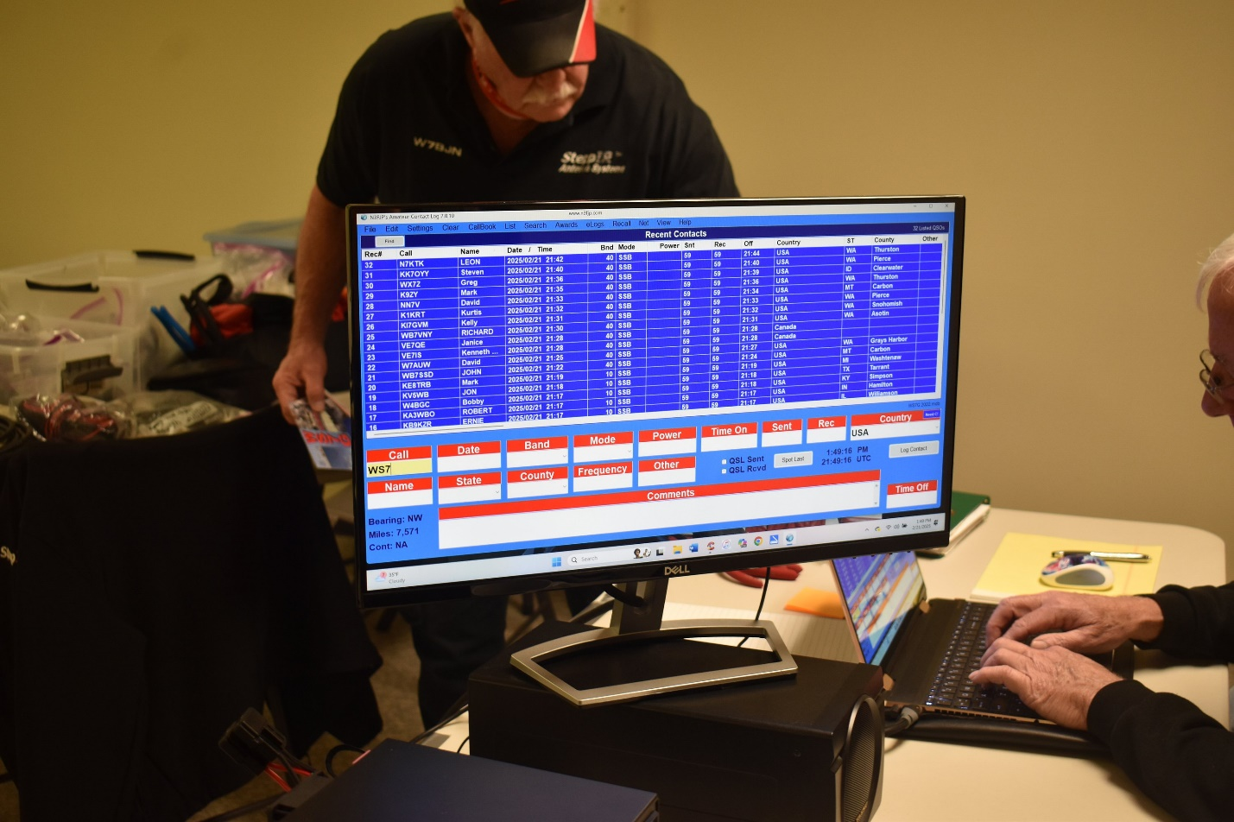 As ham users answer the Columbia Basin DX Club’s call, each responder’s call sign can be pulled up from a database, so users know whom they’re talking with.

